Building Docker in Kubernetes Cluster and deploying into Mach1ML
Instructions:
- Login to HPC account
- Generate Github SSH key.
- Add Github & Portus ssh keys into Kubernetes Secrets.
- Create Docker-Enabled POD in Kubernetes Cluster
- Build & Push Docker Image
  - Clone git repo and create docker image
  - Push the docker image to Docker Image Repository
- Deployment in Mach1Ml

Step 1: Login to HPC account:
- Login into HPC via Putty:
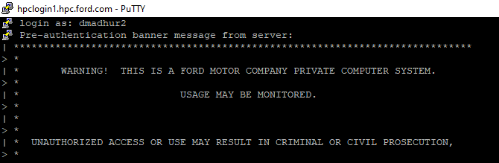
- Login to Kubernetes
Command: kubectl login
Enter your hpc password

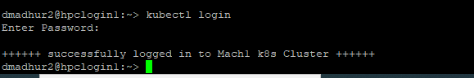
- If you face any issues after login, then it might be kubernetes configuration is not pointing to Mach1 cluster. We need to recreate the configuration.
Command: cd ~/.kube
cat config
In the below example, the config file under .kube folder is pointing to “api-caas-ford.com” instead of Mach1 cluster.
To recreate the config file:
Command: mv config config_openshift3
Here, we are renaming the config file to config_openshift3. (You can rename the file to any name)

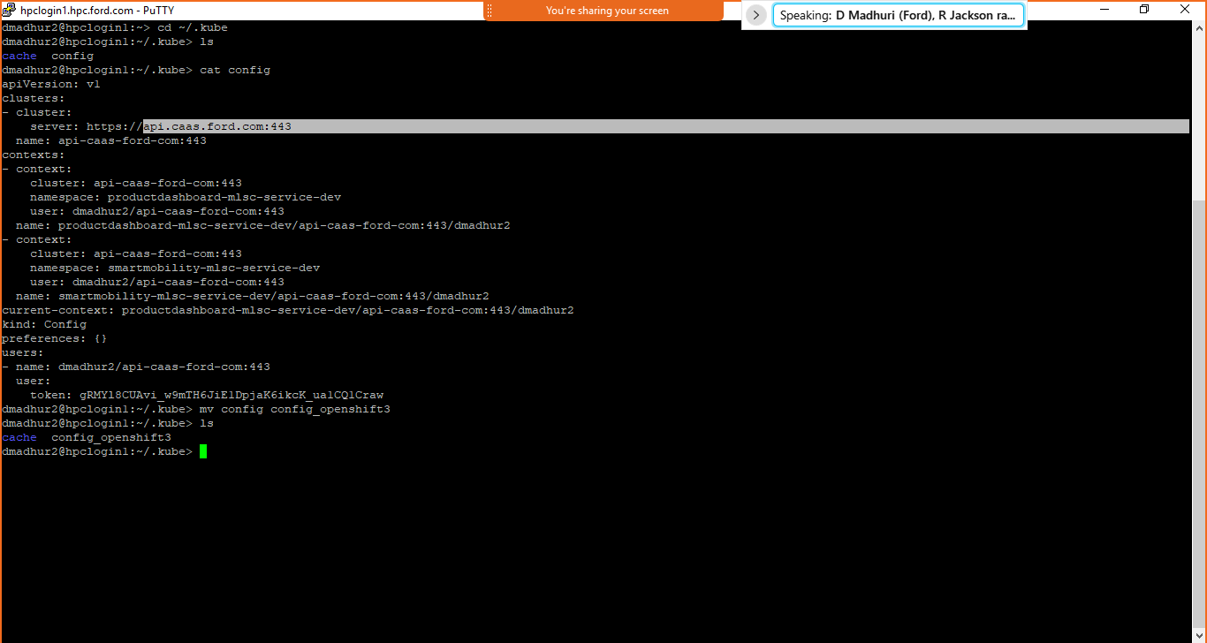

- Exit hpc and login again.
Login to Kubernetes:
Command: kubectl login
Enter your hpc password
Check the config file if its pointing to Mach1 cluster now.
Command:
cd ~/.kube
cat config
You can see from the below screenshot, its pointing to Mach1 cluster.
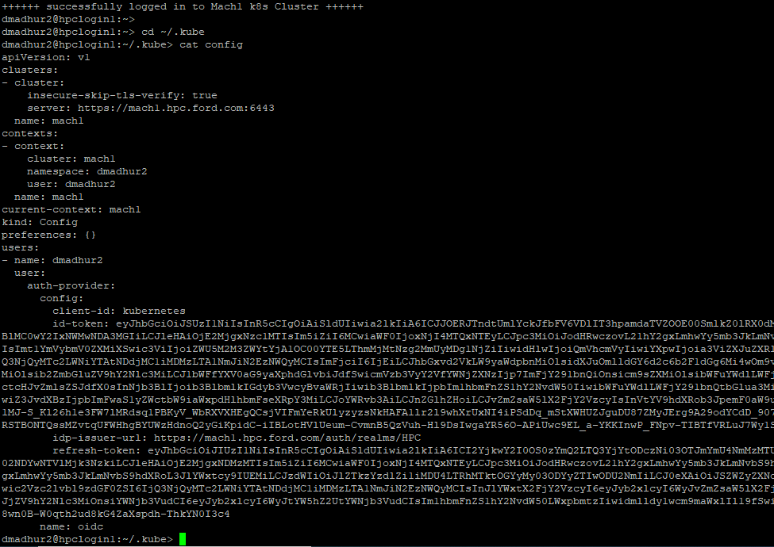

Step 2: Generate and Add Github SSH key:

- Create Github ssh key in HPC
Follow the instructions from the below link to generate ssh key and add the key to ssh-agent
https://docs.github.com/en/github/authenticating-to-github/generating-a-new-ssh-key-and-adding-it-to-the-ssh-agent
Use the Linux OS commands
Note: Don’t give the passphrase while generating the key
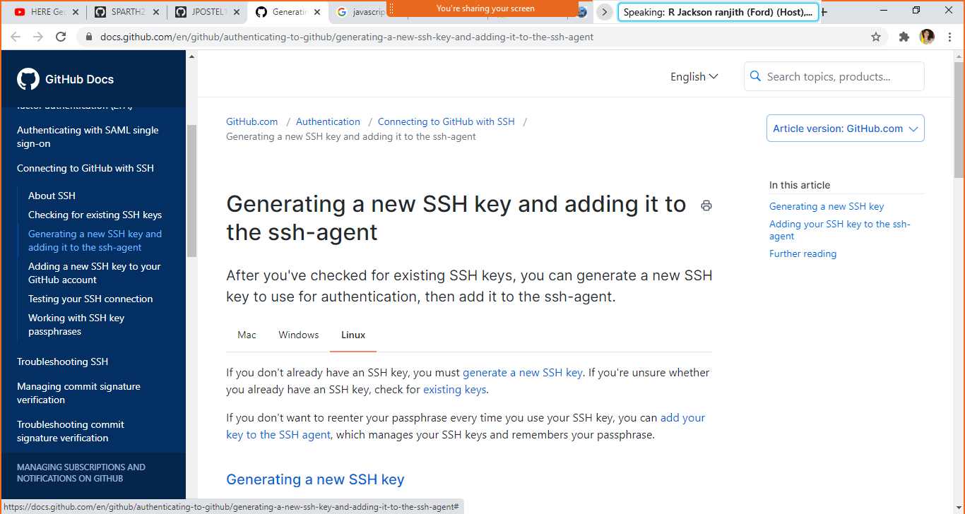
- Adding ssh key to ssh-agent
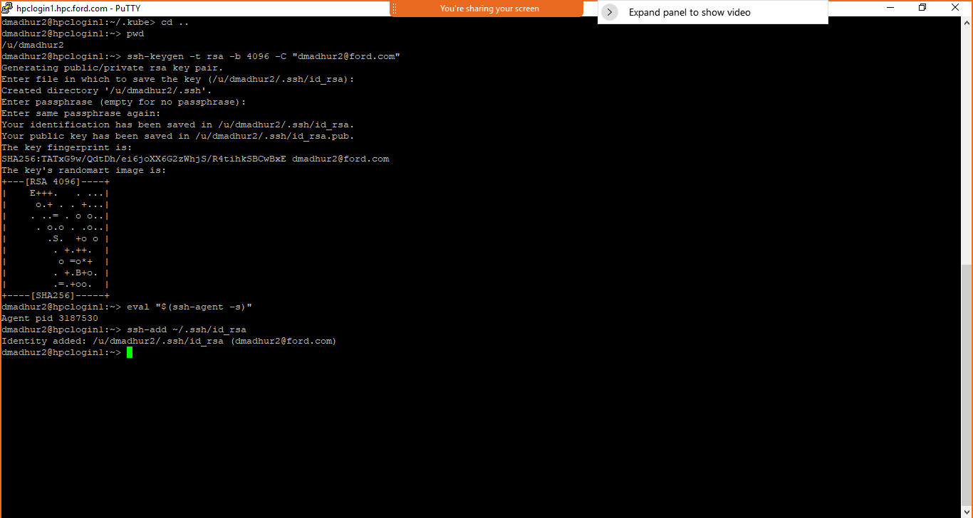

- Add the ssh key in Github settings
Go to settings under your profile. Click SSH and GPG keys.
Add the new HPC SSH Key and save.
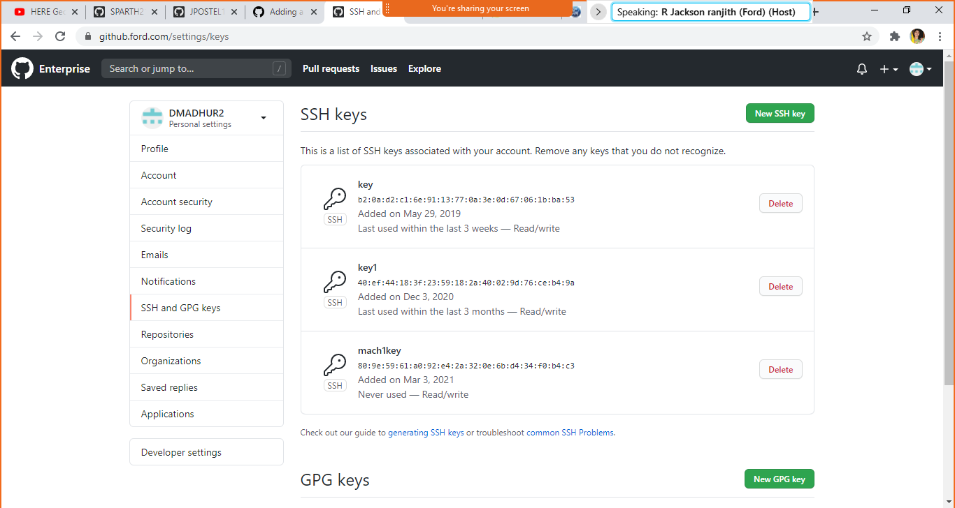

Step 3: Add Github & Portus ssh keys into Kubernetes Secrets:
1. Create secret keys for Github and Portus
Portus Secret
Command:
kubectl create secret docker-registry portus-registry-credentials --docker-server=hpcregistry.hpc.ford.com --docker-username=your_cdsid --docker-password=your_hpc_password

For Quay: download secret(service.yml) - ignore this step if you are able to create portus secret.
kubectl create -f service.yml --namespace=mobility-analytics

Issue: If you are not able to create or access secrets and facing below error
Error from server (Forbidden): error when creating "bdamayan-secret.yml": secrets is forbidden: User "bdamayan" cannot create resource "secrets" in API group "" in the namespace "mobility-analytics"
You need to raise a ITConnect ticket for docker access using below link
https://azureford.sharepoint.com/sites/hadoopservice/deeplearning/Pages/Request-Docker-Access.aspx
mention: I have access to hpc , need access to Kubenetes cluster and the error under description for Itconnect ticket.

Github SSH secrets
- Go to your U drive in hpc - cd /u/dmadhur2/.ssh
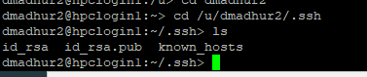
- List the files - ls
- Check whether you have git public and private keys (Keys generated from Step 2 from this document.
- Execute
Command:
kubectl create secret generic ssh-keys --from-file=id_rsa=$(readlink -f /u/dmadhur2/.ssh/id_rsa) --from-file=id_rsa.pub=$(readlink -f /u/dmadhur2/.ssh/id_rsa.pub)

Step4: Create Docker-Enabled pod:
Download the above file (remote-docker.yaml) and move this file to your hpc folder
Run the below command to spin the pod. This pod will contain docker-cli image.
kubectl apply -f remote-docker.yaml
To view the pods, use the below command
kubectl get pods
From the above screenshot, you can see the remote-docker pod is running
Note: It may take a minute to spin the pod
Get into the interactive shell of the pod
Run the below command
kubectl exec -it remote-docker bash
You will see the prompt as below
root@remore-docker:/#

Step 5: Build & Push Docker Image:

Step 5.a: Clone git repo and create docker image

Clone your code from github using below command
git clone git@github.ford.com:xxxxx/xxxx.git

git clone --single-branch --branch mobility-analytics-portal-adfs git@github.ford.com:mobility-analytics/mobility-analytics-portal.git

You can clone any or your github repo
After cloning go to your project folder
Next you can build docker image using the Dockerfile
Command: docker build -t dockerimagename .
After building docker image check the image using below command
Command : docker images

You can now run the docker command to build the docker image.

Step 5.b: Push the docker image to Docker Image Repository
You can either push the docker image to Quay(registry.ford.com) or Portus(hpcregistry.hpc.ford.com)
Command to login to docker image repository
HPC(Portus) :
docker login hpcregistry.hpc.ford.com
Quay:
Login with your credentials and push the image.
For Quay, please go through the below link
https://registry.ford.com/tutorial/
docker login command copied from quay
Login to registry.ford.com. Go to account settings. Click "encrypted password". Enter the password and submit
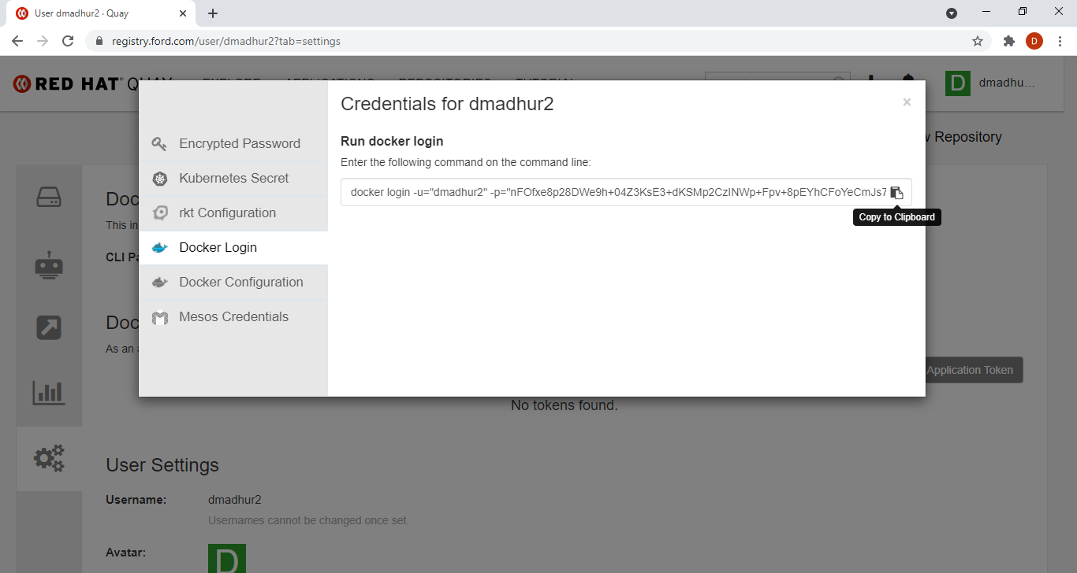

Tag the docker file
docker tag dockerimagename:latest registry.ford.com/mobility-analytics/dockerimagename:latest
docker tag face-recognition:latest hpcregistry.hpc.ford.com/dmadhur2/face-recognition:latest

Push the docker file to registry.ford.com
docker push registry.ford.com/ mobility-analytics /dockerimagename:latest
docker push hpcregistry.hpc.ford.com/dmadhur2/face-recognition:latest

Check your image in Quay

Step 6: Deployment in Mach1Ml
All projects deployment scrips are available under below git repo
https://github.ford.com/mobility-analytics/deployment

- This deployment is done with a deployment workload in kubernetes, a Service, and a VirtualService to connect to the application running in the cluster.
- In the deployment.yaml file we specify the docker image to be used, and the command to be run inside the docker image for starting the application.
- Now modify the service file to expose the running application inside the pod as a service.
- Finally, modify the routes.yaml or virtualservice.yml file to discover the service and connect to the same from a web browser.
- Now for deploying the application, navigate to the deployment directory and execute the following in HPC:
kubectl apply -f deployment.yaml
kubectl apply -f service.yaml
kubectl apply -f routes.yaml

mach1ml mobility-analytics namespace dashboard
https://mach1.hpc.ford.com/dash/#/overview?namespace=mobility-analytics
check your deployed app name as below.
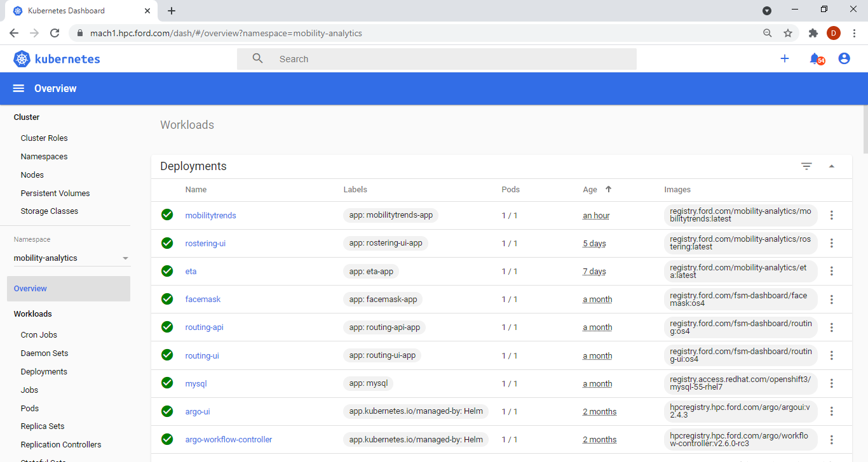

Ref:
https://github.ford.com/SPARTH21/gdia-k8s-hands-on

